24/12/2025 Influent

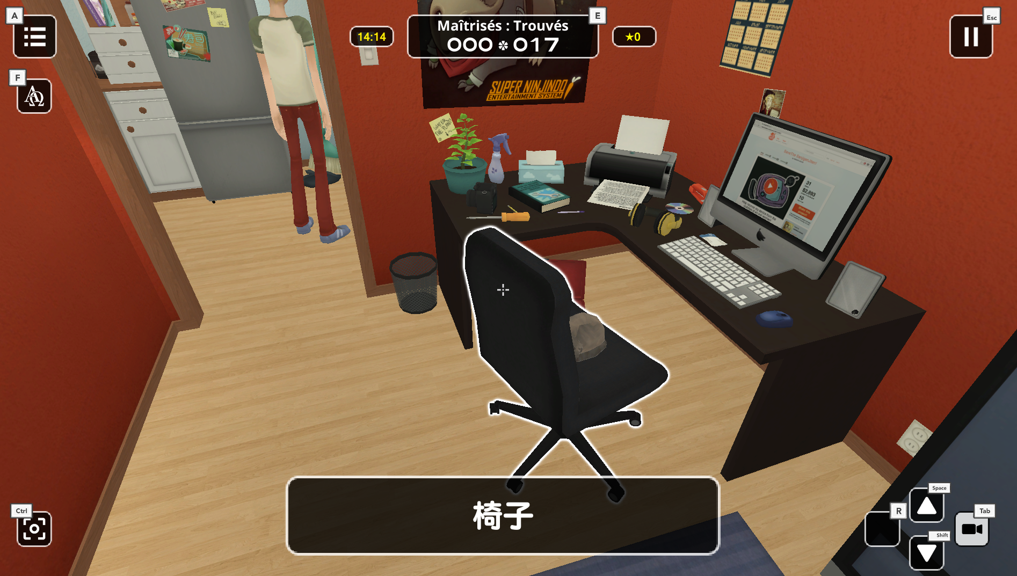

J’ai commencé le jeu aujourd’hui et c’est assez amusant.

J’ai trouvé une doc ici

1. How the game works

The point of Influent is getting a higher knowledge of (foreign) languages in a fun way.  
  
Basically, the game has 2 major tasks for you to do: collect all the words and master all those words. Before you can start mastering all the words, you need to 'collect' them by walking around the house and double-clicking every object. After you've double-clicked an item, a window will pop-up telling whether it's a noun/adjective/verbe, pronouncing the word and showing how it's written. For example the word 'Bed'.  
  
[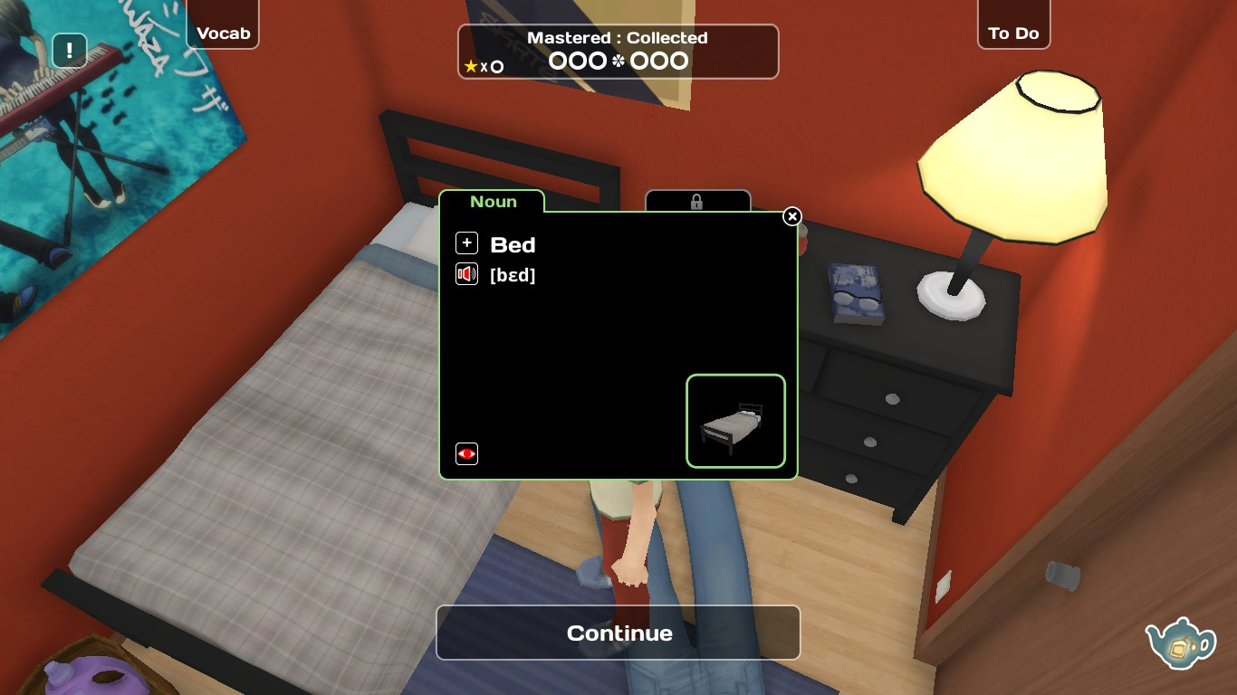](https://images.steamusercontent.com/ugc/3334094634681516464/1F7FFCF819870654CB9216BC1F009C09A8DFD7F0/)  
  
To collect the word, you have the click the '+' sign. All objects you collect are nouns like 'Bed'. Some nouns have adjectives and/or verbes connected to them. In the picture above, you can see there's a little lock-symbol at the right of the word 'noun'. Under that lock is a connected word. In this case, it's the verb 'Sleep' because normally you sleep in a bed. At the start, you can't unlock the connected words because you need stars to do it. These stars can be earned by practicing the word you've collected. To master these words, you need to click them 3 times after each other in 'Time Attack!'.  
You get a star for each word you mastered without making any mistakes. So you have to click the object 3 times correctly after each other. If you fail to do so, the star can't be earned. But don't worry too much about that. There are over 300 nouns in the game so you'll have enough chance to earn the stars and to collect more words.  
  
Now you know how to collect words, unlock connecting words and mastering them.

2. Special actions

Influent features some special actions that can be executed by right-clicking on a item. For example, in your bedroom there's a wardrobe. Normally, it's closed.[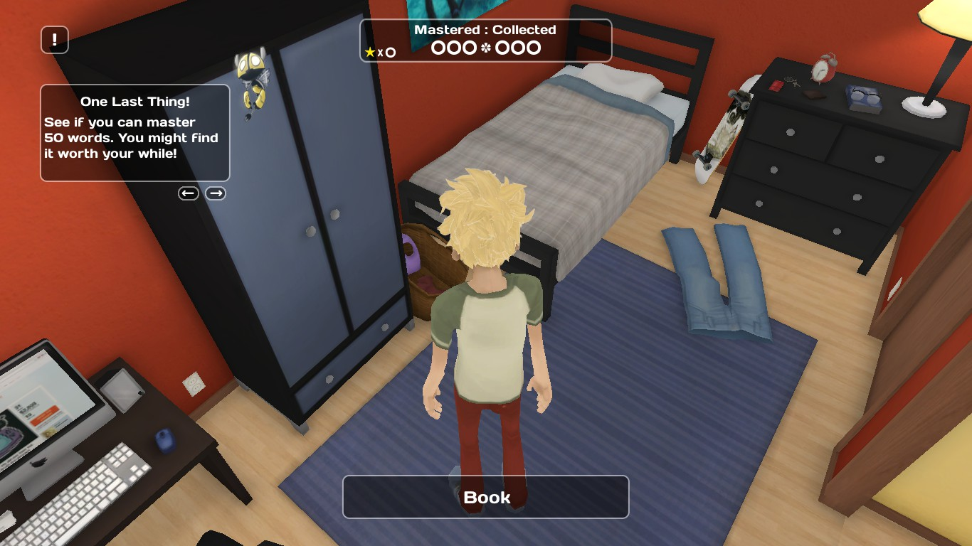](https://images.steamusercontent.com/ugc/3334094634681575985/03390EC70A41DF03F6AFC7511DAAF6240480CFE7/)  
  
  
  
  
By right-clicking it, it will open. In here you can find numerous new items to collect.[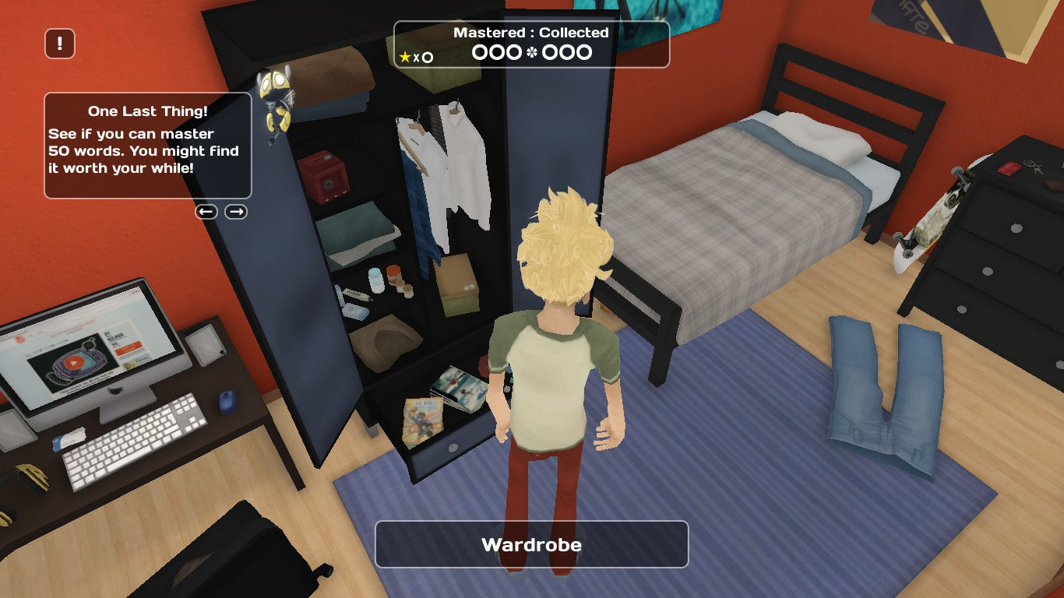](https://images.steamusercontent.com/ugc/3334094634681592997/597FBA2490D20A3A2B53003ADAD342EA22064C48/)  
  
  
  
Next to the wardrobe, there are many more items to open like the fridge, shower, oven and the TV-stand.  
  
Furthermore, you can use right-clicking to do some relatively 'funny' poop like turning the chair around with the cat on it or putting the television on.

3. Turning 1 object into multiple objects

This is a feature I discovered after being stuck at 370 words collected. I'll again take the example of 'Bed'. When you click the bed, it just says 'Bed' whether you click the pillow or you click the mattress.  
  
[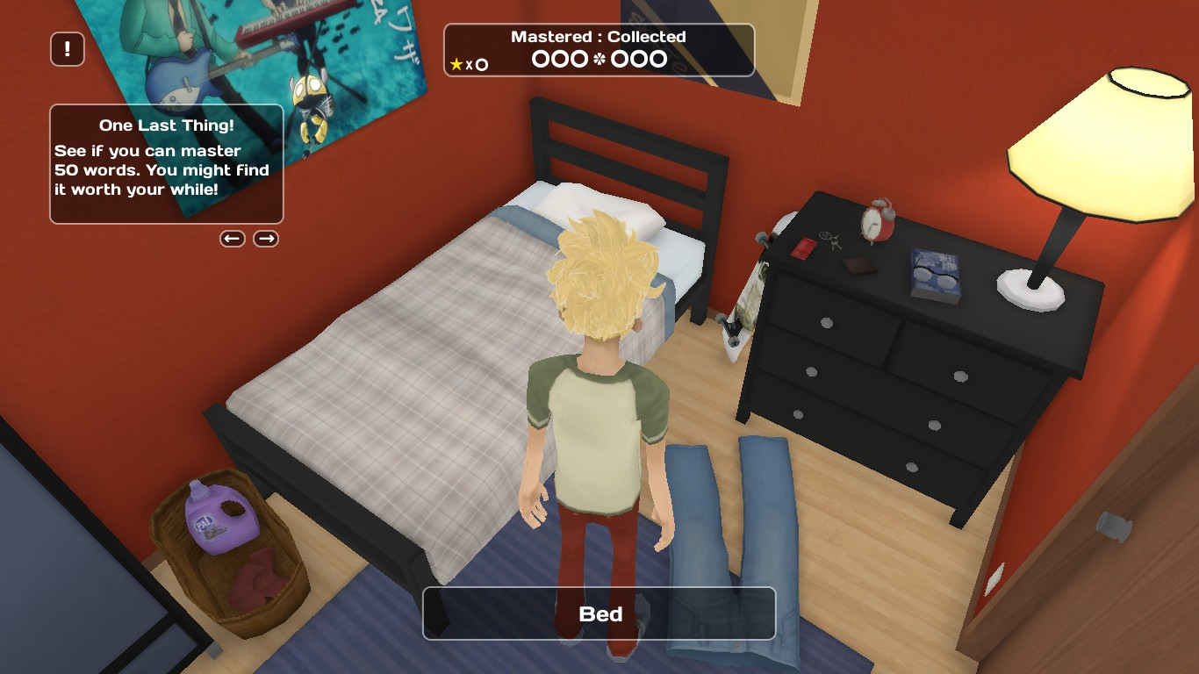](https://images.steamusercontent.com/ugc/3334094634681738996/5FAC3C2AB631F17E3811644E90488E95FD90CC14/)  
  
If you click the computer it also just say 'Computer' whether you click the mouse, keyboard or the monitor. This occurs to many items in the house, so this will be useful.  
  
Hold the left control (Ctrl) button and click on the bed again. You'll see it doesn't says 'Bed' anymore but it will say, in this case, depending on what you click 'Pillow', 'Mattress' or 'Blanket'.  
  
[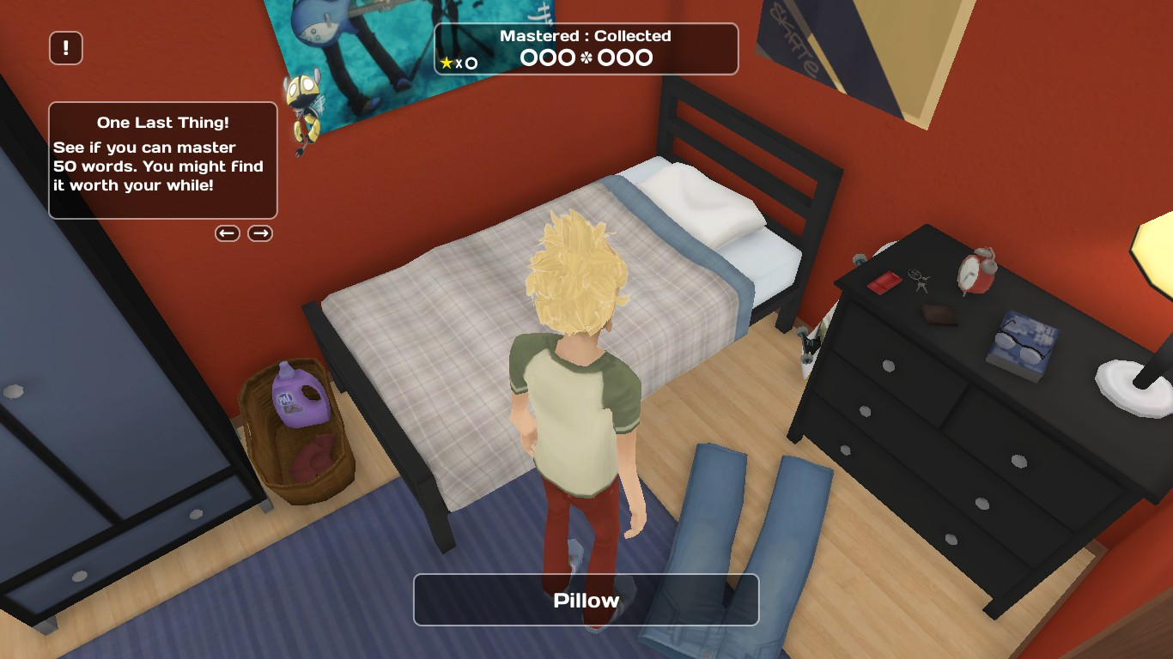](https://images.steamusercontent.com/ugc/3334094634681813585/A35AD8E27E5D3AA0D6B073EFB5CB87EFC5A15DB3/)[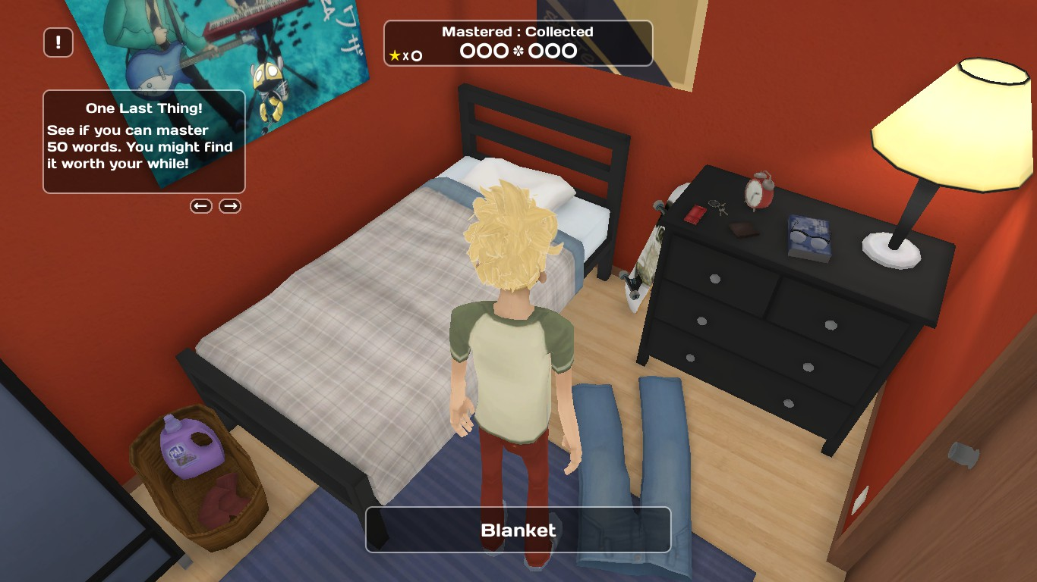](https://images.steamusercontent.com/ugc/3334094634681795616/0F61651E5D55AB6BCA33F5C11987831D51479AE7/)

4. Achievements.

If you don't care about upgrading your personal (foreign) language knowledge and you just want to get a 'Perfect Game' than I would personally suggest you don't buy Influent. It's too expensive for just getting some (useless) achievements. If you can't help it and really want to buy the game for the achievements, then I would at least buy the game in a language that you'd like to learn. That way, you get a win-win situation. I personally took 6 hours to get all words collected and mastered in English without this guide so I guess you could do it in less than 4 hours.  
  
1.Gold Star  
Master your first word!  
  
2.Blast Off  
Master 50 words and unlock Fly By!  
  
Fly By is pretty much a useless feature of the game. It's only 'useful' to get the eleventh achievement by crashing the plane.  
  
[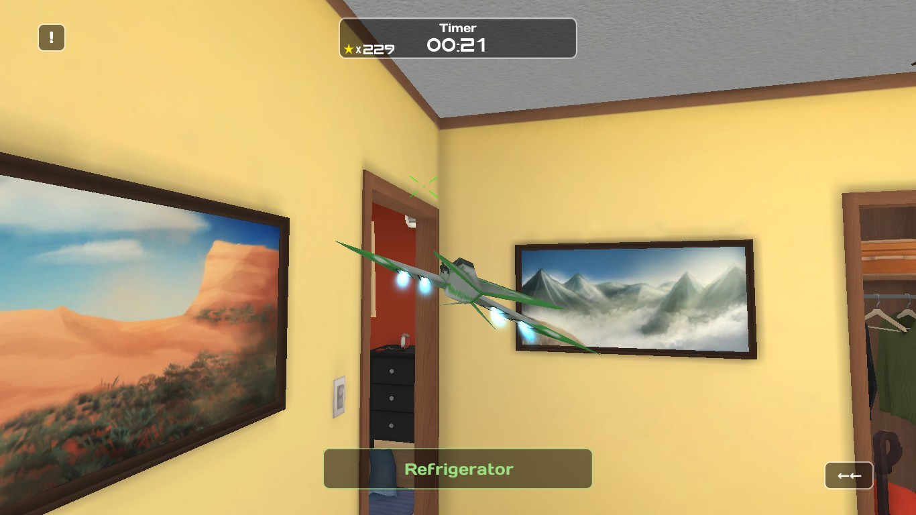](https://images.steamusercontent.com/ugc/3334094634682108483/E0F8CBFF0DDB2EED4EE0D0CB246A33BAD3FDFEE1/)  
3.100 Club  
Master 100 words!  
  
4.200 Club  
Master 200 words!  
  
5.Half Time  
Master half the words in the game!  
  
6.200 Club  
Master 300 words!  
  
7.400 Club  
Master 400 words!  
  
8.Finders Keepers  
Collect all 420 words in the game!  
  
This is probably the hardest achievement to get. I suggest when you think you've looked everywhere, you check you 'To Do List' to see what words are missing. If you already have those words, then I suggest you keep searching.  
  
9.Done Deal  
Master all 420 words in the game!  
  
Pretty easy if you keep trying. Perseverance will get you there. Promise! ;)  
  
10.Mission Improbable  
Complete all tasks on the to-do list!  
  
11.NOOOOOOOO!!!!!  
Use the FlyBy option to fly a little airplane, and than crash it.  
  
12.The Cake is a Lie  
Master the word "cake" that is hiding inside your fridge!  
  
[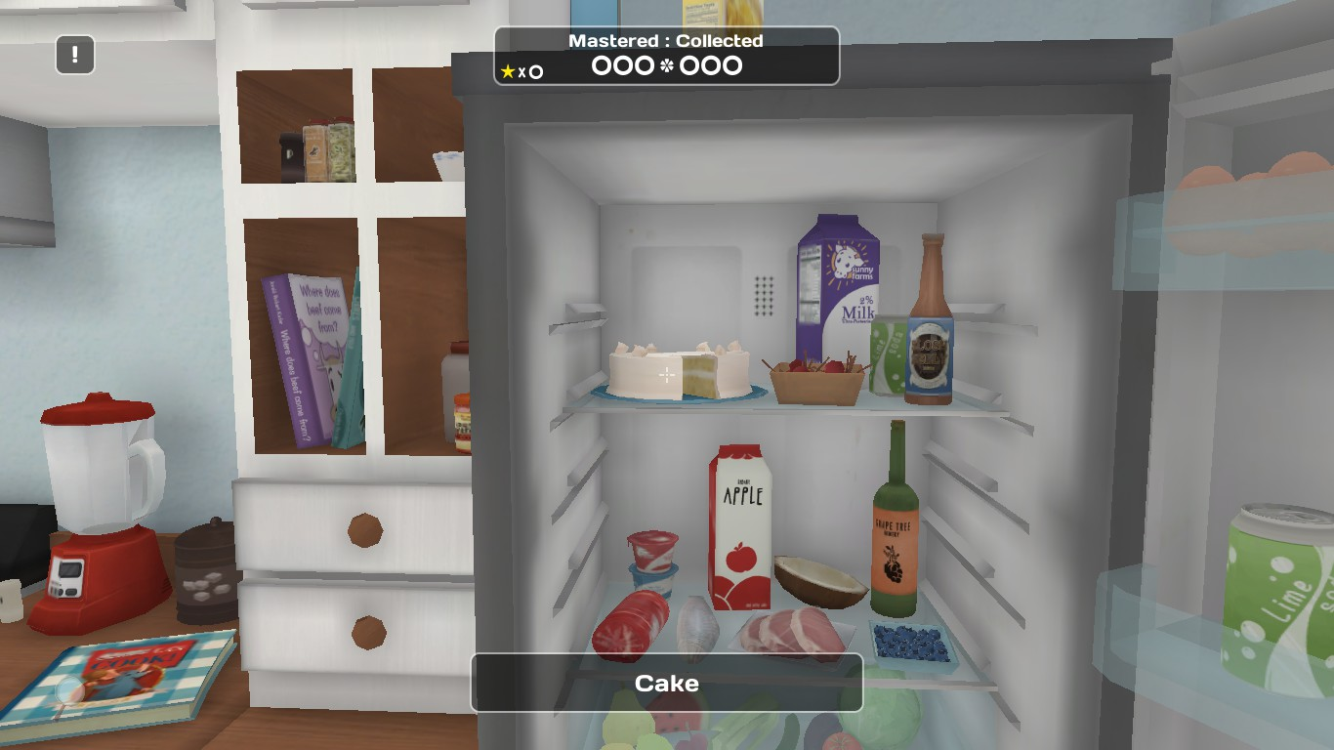](https://images.steamusercontent.com/ugc/3334094634682084036/51366A8532EAE0EE888B52C7CBE4E7BE3415DC0D/)  
Congratulations if you found all the words by yourself without using a wordlist. I'm not going to give you a list of all words, because I don't think you would learn anything by it or have any fun.  
  
Good luck and enjoy!  
Seb4nus

25/12/2025 deuxieme jour

J’ai discuté avec le createur sur linked in … super sympa je vais essayer avec d’autres langues demain

J’ai un peu triché avec google translate pourt reconnaitre les mots

